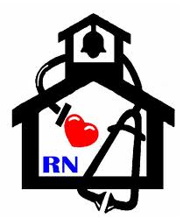
Nurse’s Nook
Pearl Lower Elementary – November 2016
Aly Weems, School Nurse
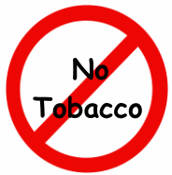Smokeless Tobacco is NOT a SAFE alternative to cigarettes! 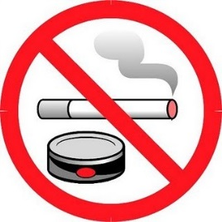

Chew, snuff, dip, spit tobacco, or smokeless tobacco - whichever term you use, it’s still tobacco, a drug that is addictive and harmful to your body.

Consequences of Smokeless Tobacco:

  - Stains your teeth and gives you bad breath. It’s an unclean habit.

  - Gum disease- causes your gums to pull away from teeth at the place where the tobacco is held. The gums do not grow back. Loss of gum tissue can lead to bone loss and even tooth loss.

  - Cavities- sugar in chewing tobacco may cause decay in exposed tooth roots.

  - Every time you chew, it increases your blood pressure and heart rate.

  - The rise in blood pressure and pulse places extra stress on your heart and may actually reduce your overall athletic performance.

  - Increases your chances of getting cancer in the mouth, esophagus, pharynx, larynx, and even the stomach. White patches called leukoplakia, red sores, and lumps are signs of tissue damage seen in chewing tobacco users. These tissue changes can turn into cancer. Oral cancer can spread to other parts of the body quickly. On the average, half of oral cancer victims pass away within five years of diagnosis.

  - Costs you money! It’s an expensive habit, and you are wasting your money on something that brings harm to your body.

- If you or a loved one needs help quitting, you can call 1-800-QUITNOW or 1-800-784-8699! It’s never too late to quit!

